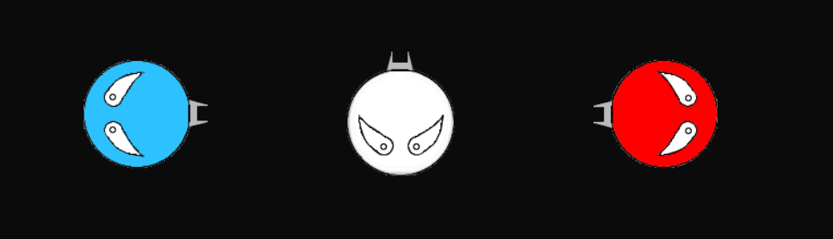

Face in Space

Game Design Document

Christopher Guzowski

**Table of Contents**

Game Pitch 2

Objective 2

Players 3

Controls 3

Game Flow 4

Modes 5

Player VS AI 5

Player VS Player 5

Future Game Developments……………………………………………………………………………………………………………………6

Side-note & Gratitude……………………………………………………………………………………………………………………………..7

# **Game Pitch**

*Not so long ago, in a space not so far away… not even over Local LAN.. but on the same machine; faces would face off! Many players would share the screen to enjoy the duo battle unfold between a couple of players sharing a keyboard. There’s also single player and they would face a AI to help improve their mastery of balancing firstly their maneuvering; as the movement mechanics are complex. Your momentum is preserved as you’re a face in space, Afterall. You have a jet behind you propelling you forward, wherever you may face. A rotating face hasn’t been unheard of in this universe, that’s the key to changing trajectory! Once you learn to maneuver, or even if you don’t, you can put your focus into firing instead! You can fire “pellets” as quick as the computer can catch all your fire keystrokes! To do this, you’d probably need to sacrifice mobility and accuracy, unless you’re talent gifted. Ultimately your balance of movement, accuracy and fire rate with finger management will be what will get your face to first place in space! Lastly, the camera always needs to face you so a vortex will keep your faces in check, don’t worry!*

# **Objective**

*The objective of the game is to land enough pellets on your opponent which would take their face out of your space. With every shot landed, a face will shrink bringing It closer to seizing from existing. This balances out the playing field as it gets harder to land shots giving potential for players to comeback seeking revenge from being pelleted. Once a player dies, they fall face first, literally! The game ends there, but it doesn’t have to as you can tell by your opponents face they aren’t too pleased with the results.*

# **Players**

|  |  |  |
| --- | --- | --- |
| **Player 1** | **Player 2** | **AI** |
|  |  |  |

# **Controls**

|  |  |  |  |
| --- | --- | --- | --- |
| **Action**  **Button key** | **Move forward**  **(Activate Jet)** | **Turn Left / Right** | **Use Weapon / Fire** |
| **Player 1 Button Key** | S | A / D | W |
| **Player 2 Button Key** | Down Arrow | Left / Right Arrows | Forward Arrow |

## Mouse

* Confirm: Left Click (To navigate menu options)

# **Game Flow**

As the game is still developing many new features, it provides a simple menu with a couple of exciting options. The player(s) may choose from either facing a friend or foe in real life, or the computer that’s running the game itself; as depicted below by the following diagram:

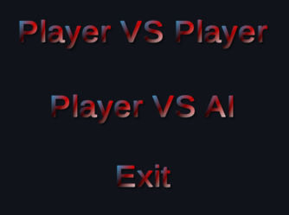

Closes the game (program)

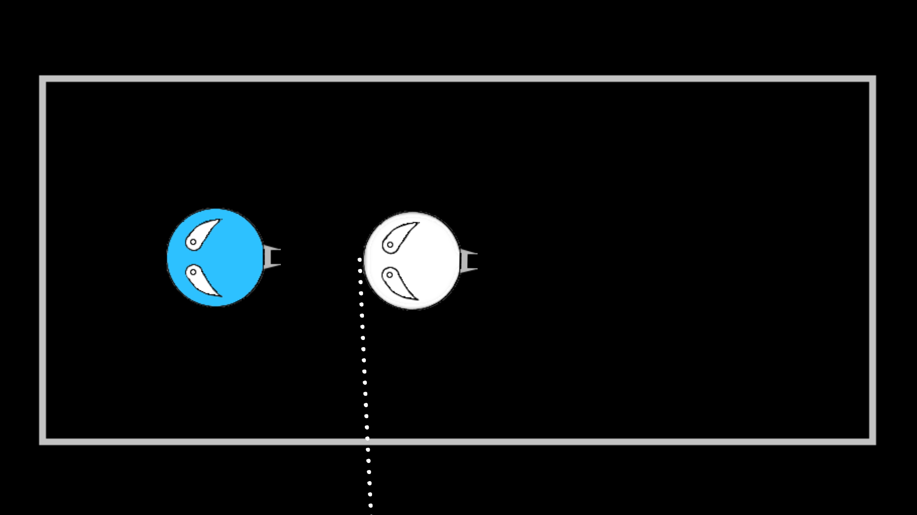 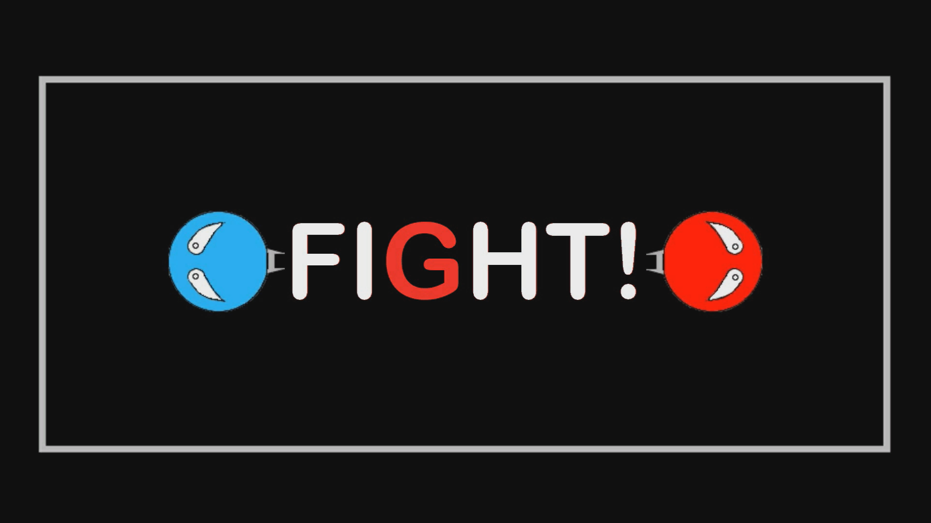

A Face seizes to exist

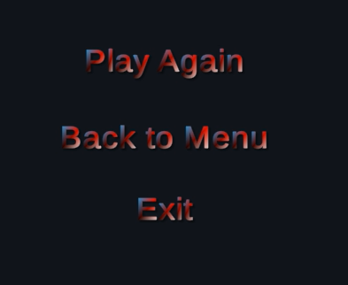

## **Modes:** Below are the current game modes available, for now!

|  |  |
| --- | --- |
| **Player VS Player**  Here Players share a keyboard to face off!        (awkward) | **Player VS AI**  Here a player can practice against an AI (I purposely made the AI shoot awkwardly so the player stood a chance, and can learn a thing or two).      (Look at that pellet stream of a fire rate!) |

## **Future Game Developments**

* More players available per fight
* AI available (easy, medium & hard)
* Over the internet (Multiple devices synced real-time)
* Pellets and face skins will be customizable and maybe even contain YOUR face! (if you so wish)
* More maps with obstacles and / or events (meteoroids, shooting stars, black holes,).
* And, a much needed feature in my opinion which I tried to develop before play-test day, a pellet system where if you don’t fire the pellet, it will grow over time to a medium size pellet doing twice as much damage as a small pellet and will move faster. If the player still doesn’t shoot the pellet it will become its final size, a large pellet moving even faster doing twice as much damage as a medium shot. Here we witness an exchange for firing speed and trying to land shots more accurate shots. Also the behavior of players would be more understood as a player with a bigger pellet will be more dangerous so the other should try dodge it while building their own.

**Side-note & Gratitude**

I’m proud of the games I made and developed, especially this game right here. I will continue to work on this till I feel it’s ready and will attempt to put it on the android market / on-line.

I’m grateful to my classmates and my Professor Tamrah Cunningham, and a special thank you to her. I had a pleasant time in your class which made the learning experience that much more meaningful. Please keep up the amazing work that you do.

Sincerely your student, Christopher

Guzowski